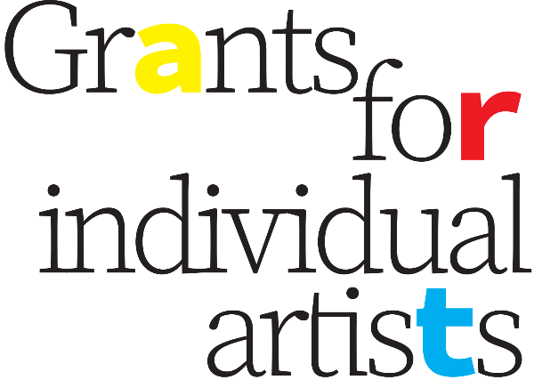

**Grants for Individual Artists Application Form**

**Component One**

**Mini Development Grants for Individual Professional Artists**

**NOTE:** Please ensure you are filling out the application form for the correct Component of this program. The application form for Component Two, as well as the full Program Guidelines, can be found on the [Grants for Individual Artists website](https://www.ecthree.org/program/grants-for-individual-artists-2024/).

Applications accepted only via this Word document form, saved as a doc/docx, and sent by email to [ec3interimprogramcoordinator@gmail.com](mailto:ec3interimprogramcoordinator@gmail.com) with the subject line “Application: GFIA Component One.”

**Name of lead applicant:**

**Name of who the cheque should be made out to:**

**Other confirmed participants** (if applicable):

**Contact information for lead applicant:**

**Phone** (required):

**Email** (required):

**Mailing address** (required):

**Eligibility:***Please review the criteria below and confirm that you meet all the eligibility requirements.*

* I am a Canadian citizen, permanent resident, or a person upon whom refugee protection has been conferred, and I am legally entitled to work in Ontario.
* I am a Peterborough City or County Resident (including Curve Lake and Hiawatha).
* I am a Professional Artist (see definition in Program Guidelines – Eligibility Criteria).
* I am age 18 or over.
* I have completed and submitted all outstanding reports from any previous EC3 grants I have received, and had those reports approved.

**Do you meet all the eligibility requirements?**

**Grant request** (up to $1,500.00):

**Project start and completion dates (if known):**

**TITLE OF PROJECT:**

**PROJECT DESCRIPTION SUMMARY** (25 words maximum):

*Briefly describe how you would use the requested grant. Please be as specific as possible. (Previous examples include “Research, writing, illustration planning, development, and artist fee to create a children’s picture book” and “Artist fee for the revision of a suite of poems written in the last months of my mother’s life.”) If your application is approved, this summary will be used for media purposes.*

**ARTIST’S STATEMENT/PROGRAM OF ACTIVITIES/PROJECT PROPOSAL OR DESCRIPTION:**

*Describe what you want to do and why you want to do it. What are the artistic goals of your project/program of activities? How would this grant help you to accomplish your artistic goals and objectives? Your artist’s statement should explain how the proposed program of activities or work either contributes to the development of your artistic practice, or a particular project.*

**SUPPORT MATERIALS:**

*Please remember that the assessment of your grant proposal will include an evaluation of your support materials. Provide up to 5 examples documenting your previous work as email attachments (or list links below for audio/video) with your grant application. You may also submit material illustrating your proposed activities if applicable.*

* ***Images:*** *Send in JPG/PNG/GIF format.*
* ***Audio and/or video:*** *Upload clips to the web and include link below. For clips longer than 5 minutes, please note in the description below which 5-minute segment should be considered by the jury.*
* ***Text documents:*** *Send in DOC/DOCX/PDF format.*

*Please fill out the following table identifying your Support Materials:*

|  |  |  |  |
| --- | --- | --- | --- |
|  | **Image, Audio, Video or Document Name** | **Description** | **Link (if applicable)** |
| **1** |  |  |  |
| **2** |  |  |  |
| **3** |  |  |  |
| **4** |  |  |  |
| **5** |  |  |  |

**ARTISTIC C.V./ RESUME**

*Copy and paste below or include as email attachment labelled “CV_LastName.doc”.*

**COMPONENT ONE BUDGET DESCRIPTION**

*Please briefly describe how you would spend your Component One grant of up to $1,500. (Examples include: paying artist fees to yourself or others, travel, professional development, workshop fees, research materials, etc.) If your project relies on other external sources of funding, please explain if that funding is confirmed or still pending.*

**Applications only accepted via email to** [**ec3interimprogramcoordinator@gmail.com**](mailto:ec3interimprogramcoordinator@gmail.com) **with the subject line “Application: GFIA: Component One.”**

**For further information or support, contact:**

Gabe Pollock

GFIA Program Coordinator

[ec3interimprogramcoordinator@gmail.com](mailto:ec3.research@gmail.com)

[www.ecthree.org](http://www.ecthree.org)

**Component One Application Checklist***Please review the application checklist and be sure you’ve provided all the necessary information.*

* Title of Project
* Project Summary (25 words maximum)
* Artist’s Statement/Project Description
* Support Material (up to 5 examples)
* Artistic Resume/C.V. (3 pages max)
* Budget Description

**Timeline / Deadlines**

* Friday, May 31, 2024: Call for Applications
* Thursday, June 13, 2024: Virtual Application Workshop (additional workshops as announced)
* Thursday, July 11, 2024: Call for Applications Deadline (at 11:59 pm ET)
* August 2024: Results Announced

EC3 is grateful for the generous support of all the funders who make our work possible, and particularly to the City of Peterborough for their direct support of this program.



