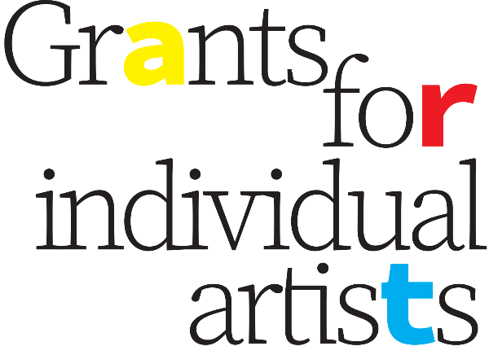

**Grants for Individual Artists Application Form**

**Component Two**

**Project Production and Presentation Grants for Individual Artists**

**NOTE:** Please ensure you are filling out the application form for the correct Component of this program. The application form for Component One, as well as the full Program Guidelines, can be found on the [Grants for Individual Artists website](https://www.ecthree.org/program/grants-for-individual-artists-2024/).

Applications accepted only via this Word document form, saved as a doc/docx, and sent by email to [ec3interimprogramcoordinator@gmail.com](mailto:ec3interimprogramcoordinator@gmail.com) with the subject line “Application: GFIA Component Two.”

**Name of lead applicant:**

**Name of who the cheque should be made out to:**

**Other confirmed participants** (if applicable):

**Contact information for lead applicant:**

**Phone** (required):

**Email** (required):

**Mailing address** (required):

**Eligibility:***Please review the criteria below and confirm that you meet all the eligibility requirements.*

* I am a Canadian citizen, permanent resident, or a person upon whom refugee protection has been conferred, and I am legally entitled to work in Ontario.
* I am a Peterborough City or County Resident (including Curve Lake and Hiawatha).
* I am a Professional Artist (see definition in Program Guidelines – Eligibility Criteria).
* I am age 18 or over.
* I have completed and submitted all outstanding reports from any previous EC3 grants I have received, and had those reports approved.

**Do you meet all the eligibility requirements?**

**Project start and completion dates:**

**PROJECT TITLE:**

**PROJECT SUMMARY** (25 words maximum):

*Briefly describe how you would use the requested funding. Please be as specific as possible. (Previous examples include: “Artist fees and venue costs to compose and present a text-based art installation based in the postmodern poetic tradition” and “A folk-rock album challenging the traditional notions of masculinity I grew up with in a small town.”) If your application is approved, this summary will be used for media purposes. Please include location(s) or platform(s).*

**PROJECT DESCRIPTION** (500 words maximum):

*Your Project Description should describe your project in detail: what the project will include, how and when it will be executed. Help the jury understand what the final product will be.*

**ARTIST’S STATEMENT** (250 words maximum):

*Describe what you want to do and why you want to do it. What are the artistic goals of your project/program of activities? How would this grant help you to accomplish your artistic goals and objectives? Your artist’s statement should explain how the proposed program of activities or work either contributes to the development of your artistic practice, or a particular project.*

**LOCATION/VENUE INFORMATION** (250 words maximum):

*Please describe the location or virtual platform that you have chosen for your project or the type of location that you are seeking for your project. For site-specific project ideas, describe how the project concept relates to the place where you would like to see it presented. Have you already secured your venue? If not, how will you secure your venue? For non-performance projects, how will your project reach the public?*

**SUPPORT MATERIALS**

*Please remember that the assessment of your grant proposal will include an evaluation of your support materials. Provide up to 5 examples documenting your previous work as email attachments (or list links below for audio/video) with your grant application. You may also submit material illustrating your proposed activities if applicable.*

* ***Images:*** *Send in JPG/PNG/GIF format.*
* ***Audio and/or video:*** *Upload clips to the web and include link below. For clips longer than 5 minutes, please note in the description below which 5-minute segment should be considered by the jury.*
* ***Text documents:*** *Send in DOC/DOCX/PDF format.*

*Please fill out the following table identifying your Support Materials:*

|  |  |  |  |
| --- | --- | --- | --- |
|  | **Image, Audio, Video or Document Name** | **Description** | **Link (if applicable)** |
| **1** |  |  |  |
| **2** |  |  |  |
| **3** |  |  |  |
| **4** |  |  |  |
| **5** |  |  |  |

**ARTISTIC RESUME/C.V.**

*Copy and paste below or include as email attachment labelled “CV_LastName.doc”.*

**COMPONENT TWO BUDGET FORM**

|  |  |  |
| --- | --- | --- |
|  | **Proposed Budget** | **Notes** |
| **REVENUE** |  |  |
| **EC3 Grant Request** |  |  |
| Other Grant Revenue *(explain, note if funding is pending/confirmed)* |  |  |
| Sponsorships/Donations |  |  |
| Box Office |  |  |
| Other Revenue *(explain)* |  |  |
| **Total Revenue** |  |  |
|  |  |  |
| **EXPENSES** |  |  |
| Artist’s Fees |  |  |
| Wages (*other*) |  |  |
| Technical Fees |  |  |
| Production Equipment |  |  |
| Production Costs (*sound, lighting, projection, venue, design, costumes, etc.)* |  |  |
| Other Production or Distribution Costs *(specify)* |  |  |
| Materials *(specify)* |  |  |
| Audience Development Materials (print, online, educational/promotional, etc.) |  |  |
| Other *(explain)* |  |  |
| Other *(explain)* |  |  |
| **Total Expenses** |  |  |
|  |  |  |
| **BUDGET SUMMARY** |  |  |
| **Total Revenue** |  |  |
| **Total Expenses** |  |  |
| **Balance** *(Revenue and Expenses must balance)* |  |  |

**Applications only accepted via email to** [**ec3interimprogramcoordinator@gmail.com**](mailto:ec3interimprogramcoordinator@gmail.com) **with the subject line “Application: GFIA Component Two.”**

**For further information or support, contact:**

Gabe Pollock

GFIA Program Coordinator

[ec3interimprogramcoordinator@gmail.com](mailto:ec3.research@gmail.com)

[www.ecthree.org](http://www.ecthree.org)

**Component Two Application Checklist***Please review the application checklist and be sure you’ve provided all the necessary information.*

* Title of Project
* Project Summary (25 words maximum)
* Project Description (500 words maximum)
* Artist’s Statement (250 words maximum)
* Location/Venue Information (250 words maximum)
* Support Material (up to 5 examples)
* Artistic Resume/C.V. (3 pages max)
* Budget Form

**Timeline / Deadlines**

* Friday, May 31, 2024: Call for Applications
* Thursday, June 13, 2024: Virtual Application Workshop (additional workshops as announced)
* Thursday, July 11, 2024: Call for Applications Deadline (at 11:59 pm ET)
* August 2024: Results Announced

EC3 is grateful for the generous support of all the funders who make our work possible, and particularly to the City of Peterborough for their direct support of this program.



